BAN 602

Case 3

Meticulous Drill & Reamer Managerial Report

Megh Dave

Manideep Elasagaram

Abhinandan Somachetty

1. Descriptive Statistics of the data from T2005: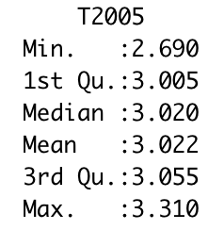

Mean = 3.022258

Median = 3.02

Standard Deviation = 0.1126265

Variance = 0.01268473

Percent error = [|(Accepted Value - Mean)|/ Accepted Value] * 100. Here, accepted value is 3 centimeters because accuracy is measured as closeness of the diameter to 3 centimeters. Therefore, percent error = [|(3-3.022258)|/3] * 100 = 0.742%. This means that T2005 produced results within 0.74% accuracy of the target diameter of 3 centimeters.

Descriptive Statistics of the data from AZ100: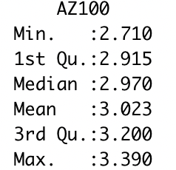

Mean = 3.022903

Median = 2.970

Standard Deviation = 0.1902664

Variance = 0.03620129

Percent error = [|(3-3.022903)|/3]*100 = 0.763%. Therefore, AZ100 drill produced results within 0.763% accuracy of the target diameter of 3 centimeters.

| Model | Target Diameter (cm) | Mean Diameter (cm) | Absolute Deviation (mean - target) (cm) |
| --- | --- | --- | --- |
| T2005 | 3 | 3.022 | 0.022 |
| AZ100 | 3 | 3.023 | 0.023 |

From the table above, it can be concluded that model T2005 is slightly more accurate than the AZ100 as the mean diameter is closer to the target of 3cm with smaller deviation.

2. Hypothesis that the T2005 and the AZ100 are equally accurate i.e. have equal means.

Step 1: State the null and alternate hypothesis:

Ho : µ1 = µ2 or µ1 - µ2 = D0 = 0

Ha : µ1 ≠ µ2 or µ1 - µ2 ≠ D0 ≠ 0

The null hypothesis states that the drill model T2005 and AZ100 are equally accurate (equal means). The alternate hypothesis is that the models are not equally accurate. Alternatively, null hypothesis emphasizes that the value of the difference in two population means is zero.

µ1 and µ2 are population means of the hole diameters of T2005 model and AZ100 model respectively.

Step 2: State the level of significance: α = 0.05

Step 3: Compute the value of the test statistic:

Here, we do not have any information about the population, but a sample of 31 observations was used. Therefore σ is not known and we will have to use t statistic.

T = (µ1 - µ2) - D0/(√ [(s1)2/n1] + [(s2)2/n2])

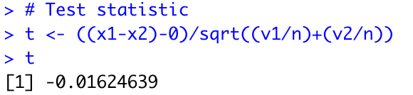Output from the code:

T = -0.016

Now,

Output from the code: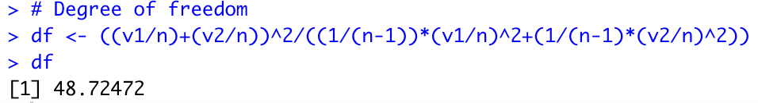

df = 48.

P-Value Approach:

Step 4: Compute the p-value.

For t = -0.016 and df = 48, p-value = 0.9871 > 0.05.

Output from the code: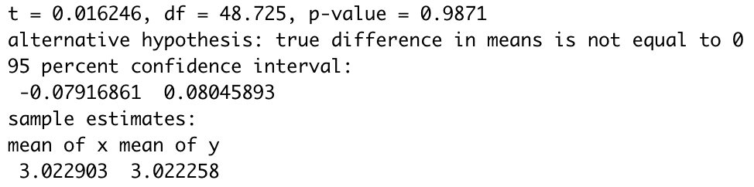

Step 5: Determine whether to reject H0.

Because p-value > α = 0.05, we cannot reject Ho. Thus, at the 0.05 level of significance, from the results of one-week trial of T2005 and AZ100 we cannot conclude that the two models are not equally accurate.

Critical Value Approach:

Step 4: Determine the critical value and the rejection rule.

For α = 0.05 and df = 48, 2.021 > t0.05 > 2.009. We will reject H0 if t ≤ -2.021 or t ≥ 2.021.

Step 5: Determine whether to reject H0.

Because -0.016 > -2.021, we cannot reject H0. This implies that we are at least 95% confident that the difference between means of holes in diameter of T2005 and AZ100 in the trial tests do not have considerable difference. Thus, we cannot conclude that the two models are not equally accurate.

3. For precision, we compare the standard deviations and variance of the two models.

| Model | Standard Deviation | Variance |
| --- | --- | --- |
| T2005 | 0.1126265 | 0.01268473 |
| AZ100 | 0.1902664 | 0.03620129 |

As can be seen from the table, each of the hole diameters recorded by the model T2005 were closer to the target value of 3 centimeters with a deviation of only 0.11, where as the standard deviation of diameters of holes in AZ100 was almost twice that of T2005. Moreover, the variance for AZ100 is close to 3 times the variance for T2005. This clearly indicates that model T2005 drills holes with more precision.

4. Hypothesis that the T2005 and the AZ100 are equally precise i.e. have equal variances.

Step 1: State the null and alternate hypothesis: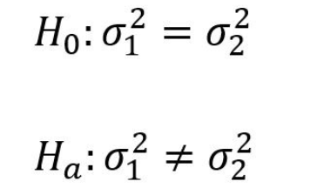

The null hypothesis states that the drill model T2005 and AZ100 are equally precise (equal variances). The alternate hypothesis is that the models are not equally precise.

σ12and σ22are population variances of the hole diameters of T2005 model and AZ100 model respectively.

Step 2: State the level of significance: α = 0.05

Step 3: Compute the value of the test statistic:

Since we are comparing the variances of two samples we will use F test statistic. Where F = s12/s22 where s12 is the larger sample variance. Thus, F = 2.8539.

Output from the code:Image

Now, with α/2 = 0.025, df numerator = 31-1 = 30 = df denominator, F0.025 = 2.074 (from F-table). We reject H0 if F ≥ 2.074. Since, F = 2.854 > F0.025 = 2.074, we reject the null hypothesis. In other words, we have sufficient evidence to conclude that the variance for T2005 and AZ100 differ. Therefore, they are not equally precise.

P-Value Approach:

Step 4: Compute the p-value.

P-value = 0.005317

Step 5: Determine whether to reject H0.

Because p-value = 0.005 ≤ α = 0.05, we reject Ho. Thus, at the 0.05 level of significance, from the results of one-week trial of T2005 and AZ100 we conclude that the two models are not equally precise.

5. From the above descriptive statistics and hypothesis testing it can be known that Davis Drills’ T2005 drill produced more accurate and precise results during the one-week trial than Worth Industrial Tools’ AZ100 model. Although, from the hypothesis we could not conclude that model T2005 is more accurate, it could be seen that it was marginally better as it produced more results with closeness of the diameter to 3 centimeters. However, it was clearly established that model T2005 was more precise as it had smaller deviation and variance from the target diameter of 3 centimeters.

Considering all factors, we recommend that MD&R should purchase Davis Drills’ T2005 model over Worth Industrial Tools’ AZ100 model to drill more precise holes.